SmartSpray — Security & Access Document
Document type: Security & Access Architecture
Product: SmartSpray AI Precision Sprayer
Audience: Product team, software team, embedded team
Security level: Early-stage / hackathon MVP, designed so it can later evolve into production

1. Executive Security Position
The most important security fact about SmartSpray is this:
This is not just a mobile app. It controls a physical pump.
A normal app bug might display the wrong number.
A SmartSpray bug could potentially cause the pump to run when it shouldn't.
Therefore, authentication and authorization are important, but hardware safety is even more important.
The system should have three independent protection layers:
📱 Flutter
│
Authorization
│
▼
💻 FastAPI
│
Command validation
│
▼
ESP32
│
Hardware limits
│
▼
💧 PUMP
If any software layer fails, the ESP32 must still enforce safe limits.
And there must be a physical emergency stop that does not depend on the phone, laptop, Wi-Fi, or AI.

2. Security Goals
We want to protect five things:

1. The physical device
Prevent unauthorized people from controlling the pump.

2. The farmer/operator
Prevent accidental or malicious spraying.

3. AI decisions
Prevent fake or corrupted commands from becoming physical actions.

4. User data
Protect detection history, device information and user information.

5. System availability
The device should fail safely rather than behaving unpredictably when something disconnects.

3. Recommended Authentication Strategy

For the hackathon MVP: Device Pairing
I would not build a complicated login system for V1.
You don't need:
- Google login
- Facebook login
- OTP
- Password reset
- Email verification
- OAuth
- Multi-factor authentication
That is wasted development time for this prototype.
Instead, use:

Local device pairing
When the SmartSpray device is first configured, it generates a pairing code.
Example:
SMARTSPRAY DEVICE

Device: SS-001

PAIRING CODE:
472 891

Expires in: 10 minutes
The user enters this into the Flutter app.
After successful pairing:
📱 Phone
│
│ authenticated device token
▼
💻 FastAPI
│
▼
ESP32
The phone receives a locally stored authentication token.

4. Why Device Pairing Is Better for V1
Your system is intended to operate locally.
There is no reason to send authentication requests to an external cloud server.
Pairing provides enough protection for the hackathon environment while keeping implementation simple.
However:
Do not treat this pairing mechanism as production-grade authentication.
If SmartSpray becomes a real commercial product, upgrade to proper account authentication.

5. Production Authentication
If the project moves beyond the hackathon, use:

Email/password + secure session authentication
Passwords should be stored using a modern password hashing algorithm such as Argon2id, never plaintext.
Use:
User
↓
Login
↓
Password verification
↓
Short-lived access token
↓
Refresh token
Access tokens should be short-lived.
The refresh token should be stored securely on the phone using the platform's secure storage rather than ordinary preferences.

6. User Roles
For the MVP, define three roles:
ADMIN
OPERATOR
VIEWER
Do not create ten roles.
Three are enough.

7. ADMIN
The administrator owns/configures the SmartSpray device.

Admin CAN:
- Pair a device
- Rename a device
- View device status
- View AI detections
- View spray history
- Change operating mode
- Use manual control
- Use assisted mode
- Start/stop scanning
- Configure calibration
- Configure severity thresholds
- Configure spray-duration limits
- View system errors
- View users
- Add/remove operators
- Add/remove viewers
- Disconnect a device
- Update configuration
- Trigger emergency stop

Admin CANNOT:
Even an admin should not be allowed to bypass hardware safety limits.
For example:
MAX_PUMP_DURATION = 3000 ms
The admin cannot send:
PUMP = ON
DURATION = 60 seconds
The backend should reject it.
The ESP32 should reject it too.
Admin does not mean unrestricted hardware access.

8. OPERATOR
The operator is the farmer/field worker.

Operator CAN:
- View dashboard
- Connect to paired device
- View AI results
- Start scanning
- Use AUTO mode
- Use ASSISTED mode
- Use MANUAL mode
- Approve AI recommendations
- Skip AI recommendations
- Move the servo within allowed limits
- Trigger a spray within allowed limits
- Stop spraying
- View their spray history
- View device status
- Trigger emergency stop

Operator CANNOT:
- Add users
- Remove users
- Change admin permissions
- Change maximum hardware limits
- Change security settings
- Delete historical records
- Change device ownership
- Modify the AI model
- Change safety limits
This is important.
A farmer should be able to operate the machine but not accidentally reconfigure the machine's safety boundaries.

9. VIEWER
Viewer is primarily for:
- Researchers
- Judges
- Supervisors
- Demonstration users

Viewer CAN:
- View dashboard
- View current device status
- View AI detections
- View spray history
- View statistics

Viewer CANNOT:
- Start spraying
- Stop the pump
- Move the servo
- Change modes
- Change calibration
- Change device settings
- Add users
- Delete data

10. Permission Matrix
Action | Admin | Operator | Viewer
View dashboard | ✅ | ✅ | ✅
View detections | ✅ | ✅ | ✅
View history | ✅ | ✅ | ✅
Start scanning | ✅ | ✅ | ❌
AUTO mode | ✅ | ✅ | ❌
ASSISTED mode | ✅ | ✅ | ❌
MANUAL mode | ✅ | ✅ | ❌
Trigger spray | ✅ | ✅ | ❌
Move servo | ✅ | ✅ | ❌
Stop pump | ✅ | ✅ | ❌
Emergency stop | ✅ | ✅ | ❌
Configure calibration | ✅ | ❌ | ❌
Configure safety limits | ⚠️ Admin configuration only | ❌ | ❌
Manage users | ✅ | ❌ | ❌
Manage devices | ✅ | ❌ | ❌
Change AI model | ✅ | ❌ | ❌
Delete records | Restricted | ❌ | ❌
Important: even Admin cannot bypass hardware safety constraints.

11. Authorization Architecture
Never trust the Flutter app.
For example, don't assume:
Flutter says:
role = ADMIN
therefore the user is an admin.
The backend must determine the user's role.
Correct:
Flutter
↓
"I want to spray"
↓
FastAPI
↓
Who is this user?
↓
What role do they have?
↓
Are they allowed to spray?
↓
Are device conditions safe?
↓
Send command

12. Hardware Authorization
There should be two separate questions before spraying:

Question 1 — Is the user allowed to spray?
Authorization.

Question 2 — Is it safe to spray?
Safety validation.
Both must pass.
User authorized?
│
YES
↓
Device safe?
│
YES
↓
Command valid?
│
YES
↓
ESP32
↓
Pump
If any answer is NO:
Do not spray.

13. Database Security
Your earlier architecture proposed SQLite for V1.
There is an important technical issue:
SQLite does not provide native row-level security (RLS).
So don't pretend that it does.
For the hackathon:

Use application-level authorization.
FastAPI checks:
user → device → record
before returning or modifying data.

14. RLS Rules for Future PostgreSQL
If you later migrate to PostgreSQL, implement true database-level RLS.
The central rule should be:
A user can access a record only if they have permission to access the device associated with that record.

15. Device Access Model
Add a device membership table:
device_memberships
Fields:
Field | Meaning
id | Membership ID
device_id | Device
user_id | User
role | admin/operator/viewer
created_at | Date added
Relationship:
User
│
│ N:M
▼
Device
A user can have access to multiple devices.
A device can have multiple users.

16. Database RLS Rules

Devices
User can read a device if:
user has membership for device
Only Admin can modify device configuration.

Detections
User can read a detection if:
detection.device_id
belongs to a device
the user has access to
Operators cannot modify historical detections.

Spray Events
User can read spray events if:
spray_event.device_id
belongs to a device
the user has access to
Only the system should create spray records automatically.
Users should not be able to fabricate:
Spray completed
from the mobile app.

Sessions
Users can view sessions belonging to their authorized devices.
Operators can create sessions.
Viewers cannot.

Calibrations
Only Admin can read/write calibration settings.
Operators should not modify calibration.

17. Important Ownership Rule
Never trust:
device_id
sent from Flutter.
Example malicious request:
POST /spray

device_id = SOME_OTHER_DEVICE
The backend must check:
Does this user have permission for this device?
If not:
403 FORBIDDEN

18. Error Handling Philosophy
Every failure should produce two things:

User-friendly message
Example:
"The sprayer is disconnected. Check the device connection."

Technical log
Example:
ESP32_TIMEOUT
device=SS-001
command=SPRAY
timeout=2000ms
Never show users raw Python errors, stack traces or database errors.

19. Standard Error Categories
Use a consistent error structure:
{
"code": "DEVICE_OFFLINE",
"message": "The sprayer is currently offline.",
"request_id": "abc123"
}
The request_id lets developers find the exact failure in logs.

20. Authentication Errors

Invalid pairing code
User sees:
Pairing code is incorrect or expired.
Backend:
401 UNAUTHORIZED
Do not reveal whether a particular device exists.

Expired session
User sees:
Your session has expired. Please reconnect.
App should attempt refresh/re-authentication.

Invalid token
Return:
401 UNAUTHORIZED
Then clear the local session and require re-pairing/login.

21. Authorization Errors
If Viewer attempts to spray:
403 FORBIDDEN
User sees:
You don't have permission to control this device.
Do not say:
"Viewer role failed authorization policy #17."

22. Device Offline
If ESP32 is disconnected:
Flutter
↓
SPRAY
↓
FastAPI
↓
ESP32 unavailable
Response:
409 DEVICE_OFFLINE
User:
Device is offline. Spray was not started.
Never queue the spray automatically.
This is important.
If the device comes back online five minutes later, it should not suddenly execute an old spray command.

23. ESP32 Timeout
FastAPI sends:
SPRAY
but receives no response.
System should:
- Stop waiting.
- Mark command as failed.
- Attempt a safe stop.
- Notify the app.
- Log the failure.
User:
Device did not respond. No spray confirmation was received.

24. Pump Failure
Possible cases:
- Pump doesn't start
- Pump doesn't stop
- Pump power disconnected
- Pump current too high
- Pump controller fails
If you don't have a flow/current sensor in V1, you cannot know with certainty that liquid was actually sprayed.
Therefore don't display:
"12 mL successfully sprayed"
unless you actually measure it.
Instead say:
"Pump activated for 1 second."
If you later add a flow sensor:
"Measured volume: 8.2 mL."
That's an important distinction.

25. Servo Failure
Possible:
- Servo disconnected
- Servo stalls
- Servo reaches mechanical limit
Backend/ESP32 should enforce:
MIN_SERVO_ANGLE
MAX_SERVO_ANGLE
Invalid:
servo = 300°
Response:
400 INVALID_SERVO_ANGLE

26. AI Failure
AI model doesn't load:
AI_NOT_READY
User:
AI is unavailable. Manual control is still available.
If your product design permits manual operation, AI failure should not automatically disable basic hardware control.
However, manual spraying should remain subject to hardware safety limits.

27. Low AI Confidence
Suppose:
Disease confidence = 42%
Do not automatically spray.
Instead:
LOW CONFIDENCE

AI is uncertain.

[ REVIEW ]
[ SKIP ]
For AUTO mode, I'd recommend:
confidence < threshold
↓
NO AUTOMATIC SPRAY
This is a major safety feature.

28. Conflicting AI Results
Suppose successive frames say:
Frame 1 → Healthy
Frame 2 → Diseased
Frame 3 → Healthy
Frame 4 → Diseased
Don't immediately spray based on one frame.
Use a short confirmation window.
Example:
3 consecutive detections
↓
stable result
↓
decision
This reduces accidental sprays.

29. Camera Failure
If camera disconnects:
CAMERA_UNAVAILABLE
User sees:
Camera unavailable. Check camera connection.
AUTO mode should stop making new AI spray decisions.
Existing pump operation should be safely stopped if necessary.

30. Phone Disconnects During Spray
This is why the phone must not be the only safety mechanism.
Suppose:
Phone → Spray
Then phone battery dies.
The ESP32 should still have its own maximum spray duration.
Example:
MAX_PUMP_DURATION = 3000 ms
After 3 seconds:
PUMP OFF
regardless of what the phone does.

31. Laptop Crashes
If the laptop running FastAPI/AI crashes:
- Phone should show device/backend offline.
- ESP32 should stop accepting new commands.
- Pump should have a hardware timeout.
- Existing spray should terminate safely.
The physical emergency stop must remain functional.

32. Wi-Fi Disconnects
During a spray:
The ESP32 should not depend indefinitely on Wi-Fi.
Use a command timeout.
Example:
SPRAY command received
↓
execute
↓
maximum duration reached
↓
pump OFF
After connection loss:
NO NEW SPRAY COMMANDS
Do not execute stale queued commands.

33. Emergency Stop
Emergency stop is special.
It should have the highest priority.
NORMAL COMMAND
↓
STOP
↓
PUMP OFF
Once activated:
EMERGENCY STOP ACTIVE
The system should remain stopped until explicitly reset.
Do not automatically restart the pump when the connection returns.

34. Manual Mode Edge Cases

User presses SPRAY repeatedly
Don't execute:
SPRAY
SPRAY
SPRAY
SPRAY
simultaneously.
Use:
SPRAYING
state.
Additional spray commands should be rejected until the current operation completes or is stopped.

35. Mode Switching
Don't allow:
AUTO
↓
SPRAYING
↓
MANUAL
mid-spray.
Require:
SPRAYING
↓
PUMP OFF
↓
READY
↓
MANUAL

36. Duplicate Requests
Mobile networks can resend requests.
Suppose the phone sends:
POST /spray
twice.
Without protection:
Spray #1
Spray #2
could occur accidentally.
Use a unique command/request ID:
command_id = 8f92...
The backend should recognize:
"I've already processed this command."
and not execute it twice.
This is called idempotency.

37. Stale Commands
Never execute old commands.
Example:
10:00 → Spray requested
10:10 → Device reconnects
Do not spray at 10:10.
Every command should have:
created_at
expires_at
Example:
Command valid for 5 seconds
After expiration:
COMMAND_EXPIRED

38. Tank Empty
If you later add a tank sensor:
TANK_EMPTY
should prevent spraying.
If you don't have a tank sensor in V1, don't pretend the system knows the tank level.
You can manually show:
Tank level: Not measured
rather than inventing a percentage.

39. Battery Low
If battery monitoring is added:
Battery < safety threshold
→ don't start a new spray.
Current operation should finish or stop safely depending on the hardware design.
Again, don't display battery percentage unless you actually measure it.

40. Database Failure
If SQLite fails:
The system should not crash the entire physical control layer.
Example:
Spray operation
↓
Hardware executes
↓
Database write fails
Log:
SPRAY_RECORD_SAVE_FAILED
But don't retry the physical spray just because the database write failed.
Otherwise you risk:
Database failed
↓
retry entire operation
↓
SECOND SPRAY
Bad.

41. Database Corruption
If the database cannot be opened:
- Application reports database unavailable.
- AI may still run in diagnostic mode.
- Physical spraying should require an explicit safe operating path.
For the hackathon, regularly back up:
smartspray.db

42. AI Model Corruption
If the model file cannot load:
AI_MODEL_LOAD_FAILED
Do not silently use a different model.
Show:
AI model unavailable.
Manual mode can remain available if the system design permits it.

43. Model Update Security
Do not allow the phone to upload arbitrary .pt files and immediately execute them.
For V1:
Model is installed locally by the development team.
Future production version should use:
- Signed model packages
- Version numbers
- Checksums
- Controlled model deployment
- Rollback

44. Data Privacy
The system may capture images of:
- Plants
- Farms
- People accidentally passing through the camera view
Therefore:

V1
Store only images needed for development/testing.
Don't automatically retain every camera frame.
Prefer:
Detection metadata
+
optional detection image
rather than continuous video storage.

45. Sensitive Data
Avoid collecting unnecessary personal information.
For V1 you don't need:
- Farmer's home address
- Aadhaar/passport details
- Phone contacts
- Location history
- Precise GPS tracking
Collect only what the application actually needs.

46. API Security Rules
Every hardware endpoint should check:

1. Authentication
Who is making this request?

2. Authorization
Are they allowed to control this device?

3. Device state
Is the device online and ready?

4. Safety limits
Is the command within allowed limits?

5. Current operation
Is another spray already running?

6. Command freshness
Is this command still valid?
Only then:
send to ESP32.

47. Example Secure Spray Request
User sends:
{
"device_id": "device-001",
"servo_angle": 90,
"duration_ms": 1000,
"command_id": "abc123"
}
Backend checks:
Authenticated? YES
User authorized? YES
Device online? YES
Mode allows spray? YES
Emergency stop active? NO
Servo angle valid? YES
Duration valid? YES
Already spraying? NO
Command expired? NO
Then:
APPROVED
↓
ESP32

48. What the ESP32 Must Independently Reject
Even if FastAPI is hacked or buggy, ESP32 should reject:
Servo angle > maximum
Servo angle < minimum
Pump duration > maximum
Unknown command
Malformed command
Expired command
Commands received while emergency stop active
Commands received while fault state active
This is your last line of defense.

49. Logging
Record security and safety events:
USER_LOGIN
DEVICE_PAIRED
DEVICE_CONNECTED
DEVICE_DISCONNECTED
MODE_CHANGED
SPRAY_REQUESTED
SPRAY_STARTED
SPRAY_COMPLETED
SPRAY_FAILED
EMERGENCY_STOP
INVALID_COMMAND
UNAUTHORIZED_REQUEST
AI_FAILURE
HARDWARE_FAILURE
Don't log:
- Passwords
- Authentication tokens
- Secret keys

50. Edge Cases Before Launch
Here is the checklist I would give the team.

Authentication
- Wrong pairing code
- Expired pairing code
- Pairing code reused
- Session expired
- Invalid token
- User removed while app is open
- Device unpaired while app is open

Authorization
- Viewer attempts to spray
- Operator attempts admin operation
- User attempts access to another device
- User sends another device's ID
- User attempts to change safety limits
- User attempts to delete protected history

Hardware
- ESP32 disconnected
- ESP32 crashes
- Servo disconnected
- Pump disconnected
- Pump stuck ON
- Pump doesn't start
- Pump doesn't stop
- Invalid servo angle
- Excessive spray duration
- Emergency stop activated
- Emergency stop reset
- Device loses power

Network
- Wi-Fi disconnects
- Phone changes Wi-Fi
- Laptop IP changes
- Backend becomes unavailable
- WebSocket disconnects
- Duplicate request
- Delayed request
- Stale request
- Network reconnects during spray

AI
- Camera disconnected
- Camera gives black frame
- Very poor lighting
- Plant not visible
- Multiple plants visible
- Two diseased plants visible
- AI confidence too low
- AI gives inconsistent results
- Model doesn't load
- Model crashes
- Wrong crop detected
- Healthy plant falsely classified as diseased

Spraying
- User presses spray twice
- User changes mode during spraying
- User closes app during spraying
- Phone battery dies
- Laptop crashes
- Pump runs longer than expected
- Tank empty
- Nozzle blocked
- Tube disconnected
- Spray target moves
- AI recommendation changes during operation

Database
- Database unavailable
- Database write fails
- Duplicate spray record
- Corrupted record
- Application restarted during spray
- Old command remains after restart

51. The Most Important Safety Rule
There is one rule I would put directly into the engineering requirements:
Never let a software failure cause indefinite pump activation.
The ESP32 needs a maximum pump runtime.
For example:
MAX_PUMP_DURATION = configured_safe_limit
When that duration expires:
PUMP OFF
No matter what:
- Flutter says
- FastAPI says
- AI says
- Wi-Fi says
The hardware turns it off.

52. Another Critical Rule

AI uncertainty must result in "don't spray."
Not:
AI uncertain
↓
spray anyway
Instead:
AI uncertain
↓
NO AUTOMATIC SPRAY
↓
Ask user / skip
This is especially important because false-positive spraying is one of the central problems your product is supposed to reduce.

53. Recommended V1 Security Scope
For the college prototype, I would implement:

MUST HAVE
- Device pairing
- Admin/operator/viewer permissions
- Backend authorization
- Hardware command validation
- ESP32 command limits
- Physical emergency stop
- Pump timeout
- AI confidence threshold
- Duplicate command protection
- Stale command expiration
- Safe failure on disconnect
- Basic security/event logging
- No secrets committed to Git

NOT WORTH BUILDING YET
- OAuth
- Google login
- MFA
- Cloud IAM
- Enterprise SSO
- Advanced intrusion detection
- Kubernetes security
- AWS security architecture
- Complex cryptographic device provisioning
Those belong in a production architecture, not your first prototype.

54. Final Security Architecture
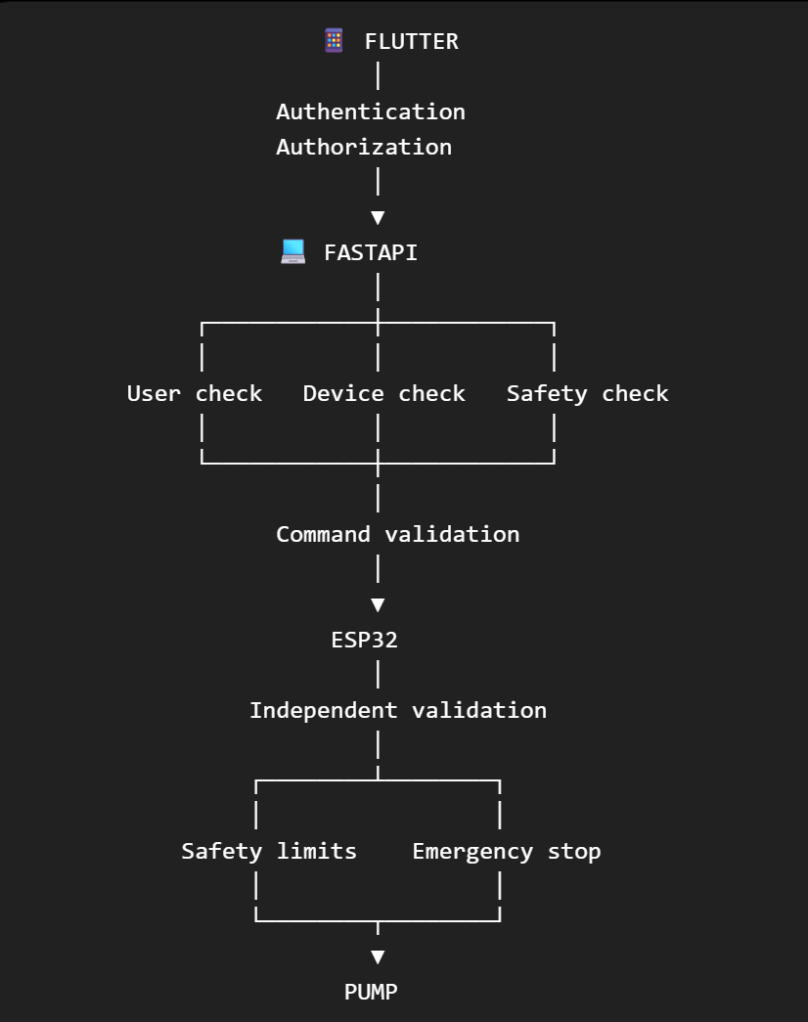The security philosophy for SmartSpray
Phone decides what the user wants.
Backend decides whether the user is allowed to request it.
ESP32 decides whether the command is physically safe to execute.
Physical emergency stop can override everything.
That's the architecture I would sign off on for your MVP. It gives you enough security to demonstrate a serious product without wasting your hackathon time building enterprise authentication that provides almost no value at this stage.

